**第一题：**

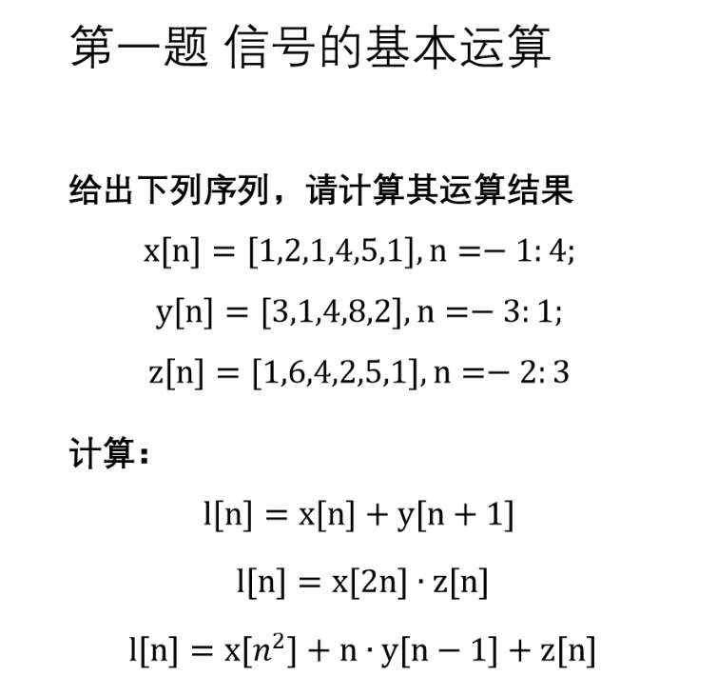

第一问可以用平移法

|  |  |  |  |  |  |  |  |  |  |  |
| --- | --- | --- | --- | --- | --- | --- | --- | --- | --- | --- |
|  |  |  |  |  |  | 零点 |  |  |  |  |
| y[n] |  | 3 | 1 | 4 |  | 8 | 2 |  |  |  |
| y[n+1] | 3 | 1 | 4 | 8 |  | 2 |  |  |  |  |
| x[n] |  |  |  | 1 |  | 2 | 1 | 4 | 5 | 1 |
| l[n] | 3 | 1 | 4 | 9 |  | 4 | 1 | 4 | 5 | 1 |

第二/三问 由于关于n不是平移运算，不能使用箭头平移法，应使用列表法

先确定的范围， 对于

所以

|  |  |  |  |  |  |  |
| --- | --- | --- | --- | --- | --- | --- |
|  |  |  |  |  |  |  |
|  |  |  | 零点 |  |  |  |
| n | -2 | -1 | 0 | 1 | 2 | 3 |
| x[2n] | 0 | 0 | 2 | 4 | 1 | 0 |
| z[n] | 1 | 6 | 4 | 2 | 5 | 1 |
| l[n] | 1 | 6 | 6 | 6 | 6 | 1 |

【？？？？？？？？？？？？？？？？？？？？？？？？？？？】

第二问：

先确定的范围， 对于

|  |  |  |  |  |  |  |
| --- | --- | --- | --- | --- | --- | --- |
|  |  |  | 零点 |  |  |  |
| n | -2 | -1 | 0 | 1 | 2 | 3 |
|  | x[4] | x[1] | x[0] | x[1] | x[4] | x[9] |
| x[n^2] | 1 | 1 | 2 | 1 | 1 | 0 |
|  |  |  |  |  |  |  |
| y[n-1] | 3 | 1 | 4 | 8 | 2 | 0 |
| ny[n-1] | -6 | -1 | 0 | 8 | 4 | 0 |
| z[n] | 1 | 6 | 4 | 2 | 5 | 1 |
| l[n] | -4 | 6 | 6 | 11 | 10 | 1 |

**第二题**

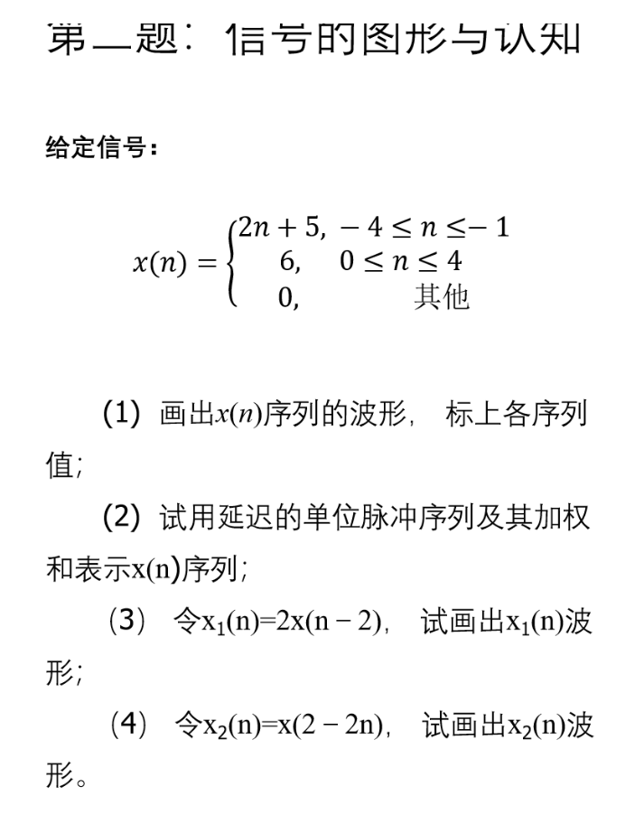

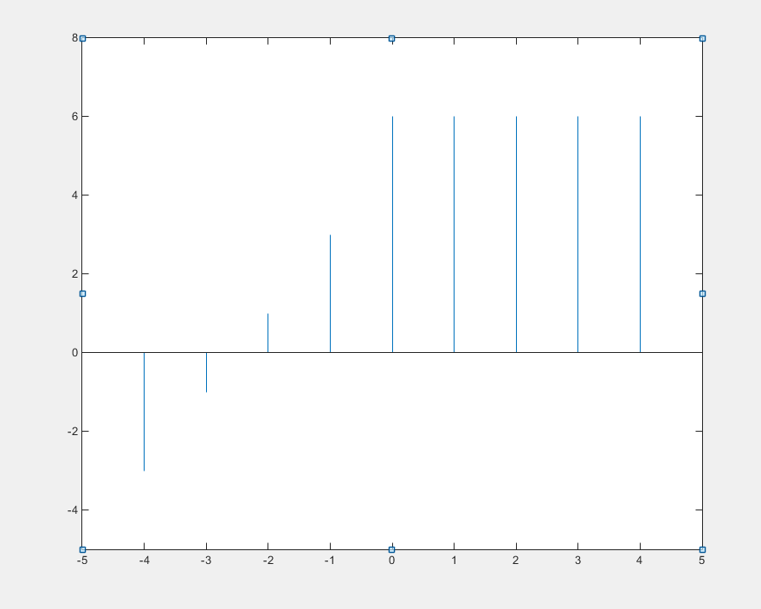

2） y =

所以

将完全展开也算对

3）

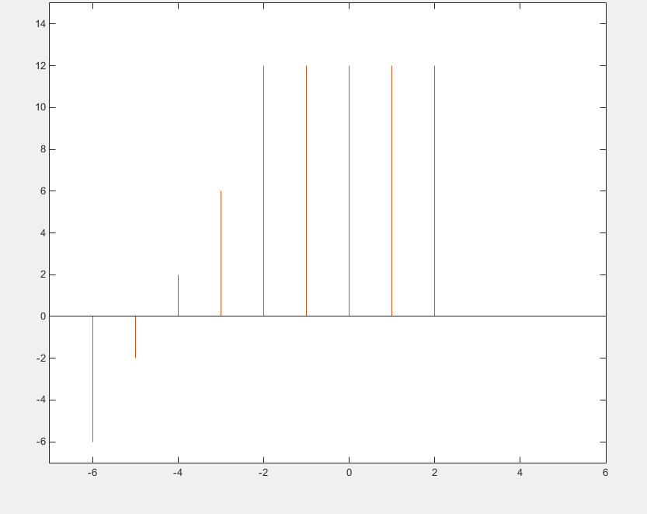？？？？？？？？？？？？？？？？？？？？？？

4）

|  |  |  |  |  |  |  |  |
| --- | --- | --- | --- | --- | --- | --- | --- |
| n | -4 | -3 | -2 | -1 | 0 | 1 | 2 |
| -2-2n | 6 | 4 | 2 | 0 | -2 | -4 | -6 |
| x[-2-2n] | 0 | 6 | 6 | 6 | 1 | -3 | 0 |

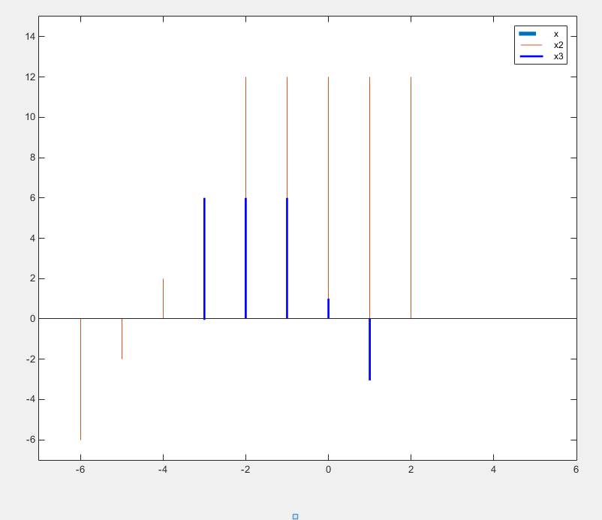

**第三题**

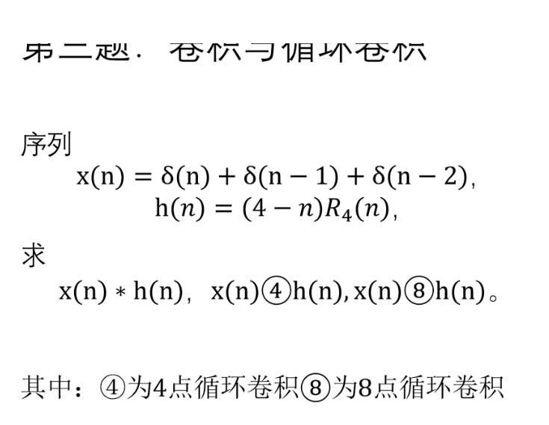

使用快速卷积则有

|  |  |  |  |  |  |  |
| --- | --- | --- | --- | --- | --- | --- |
| x[n] |  |  | 4 | 3 | 2 | 1 |
| h[n] |  |  |  | 1 | 1 | 1 |
|  |  |  | 4 | 3 | 2 | 1 |
|  |  | 4 | 3 | 2 | 1 |  |
|  | 4 | 3 | 2 | 1 |  |  |
| y[n] | 4 | 7 | 9 | 6 | 3 | 1 |

循环卷积

|  |  |  |  |  |  |  |  |
| --- | --- | --- | --- | --- | --- | --- | --- |
|  |  | 循环矩阵 | |  |  |  |  |
|  |  | h[n] |  |  | x[n] |  | y[n] |
| 4 | 1 | 2 | 3 |  | 1 |  | 7 |
| 3 | 4 | 1 | 2 | * | 1 |  | 8 |
| 2 | 3 | 4 | 1 |  | 1 |  | 9 |
| 1 | 2 | 3 | 4 |  | 0 |  | 6 |

1. 上述为矩阵和向量的乘法
2. 可以自行验证，将x[n]生成循环矩阵，将h[n]作为向量，结果一样

|  |  |  |  |  |  |  |  |  |  |  |  |
| --- | --- | --- | --- | --- | --- | --- | --- | --- | --- | --- | --- |
|  |  |  | h[n] |  |  |  |  |  | x[n] |  | y[n] |
| 4 | 0 | 0 | 0 | 0 | 1 | 2 | 3 |  | 1 |  | 4 |
| 3 | 4 | 0 | 0 | 0 | 0 | 1 | 2 |  | 1 |  | 7 |
| 2 | 3 | 4 | 0 | 0 | 0 | 0 | 1 |  | 1 |  | 9 |
| 1 | 2 | 3 | 4 | 0 | 0 | 0 | 0 |  | 0 |  | 6 |
| 0 | 1 | 2 | 3 | 4 | 0 | 0 | 0 |  | 0 |  | 3 |
| 0 | 0 | 1 | 2 | 3 | 4 | 0 | 0 |  | 0 |  | 1 |
| 0 | 0 | 0 | 1 | 2 | 3 | 4 | 0 |  | 0 |  | 0 |
| 0 | 0 | 0 | 0 | 1 | 2 | 3 | 4 |  | 0 |  | 0 |

可以看到循环矩阵当 循环长度 时 和线性卷积结果相同

**第四题**

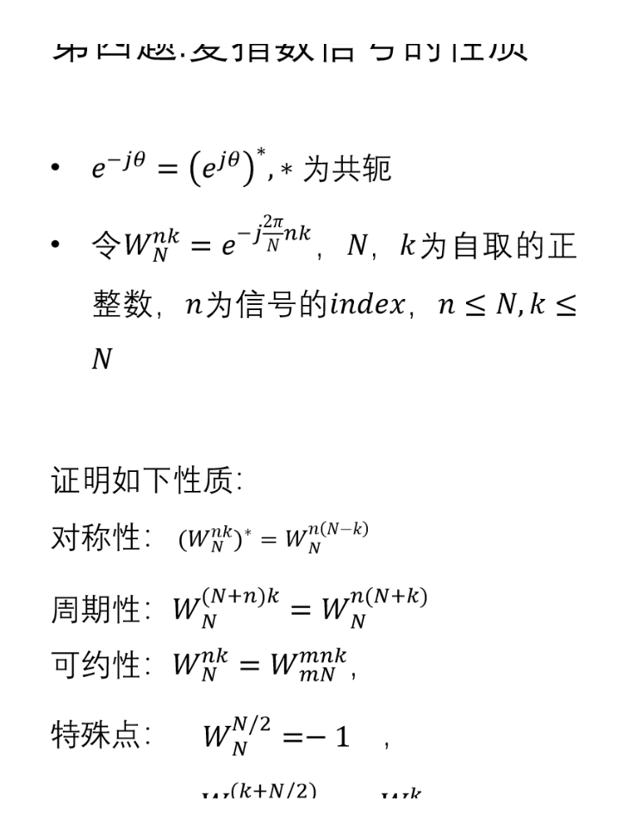

对称性

注：

周期性：

同理可知

可约性：

特殊点

此时

此时 用于快速傅里叶变换拆分到一个长度为1的序列

**第五题：**

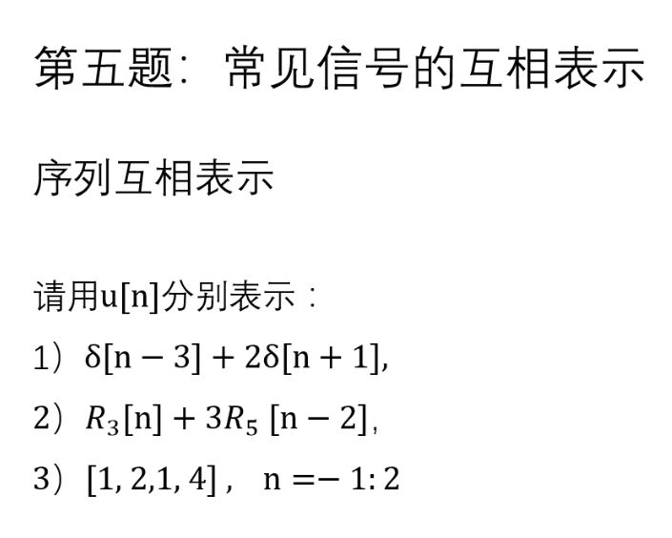



所以有



同理有

3)

**第六题：**

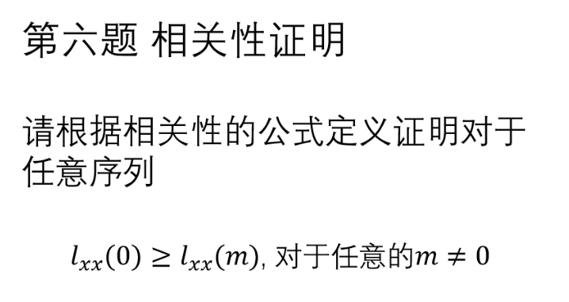

根据 相关性定义

所以有

此时对于任意的， 我们对于序列变为

此时由于是给定常数，而，

所以有

此时对于每一个, 都有

注：

所以

即

**第七题：**

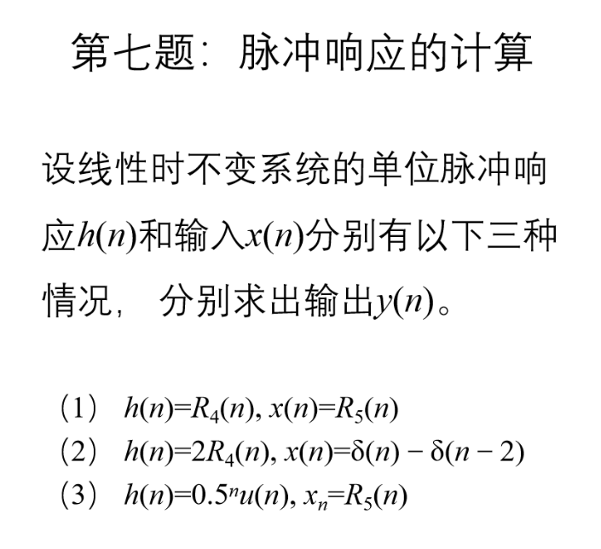

该题就是做卷积，所以前两问直接给出答案

1）

2)

3)

由定义可知，

所以

所以

这时有， 当 时， , 此时

当 时

当 时

所以综上

第八题：

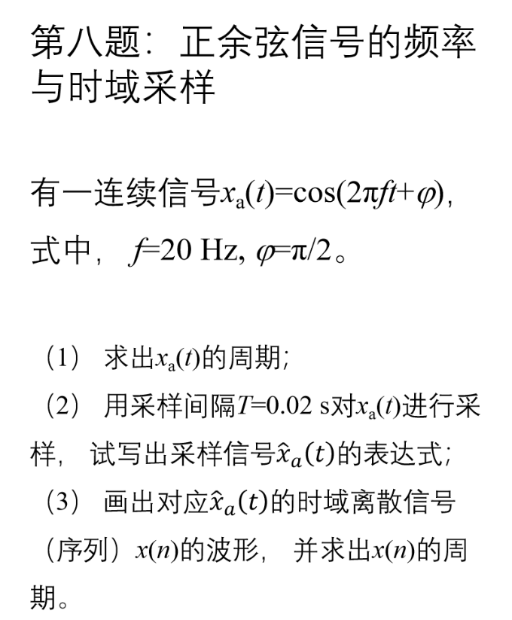

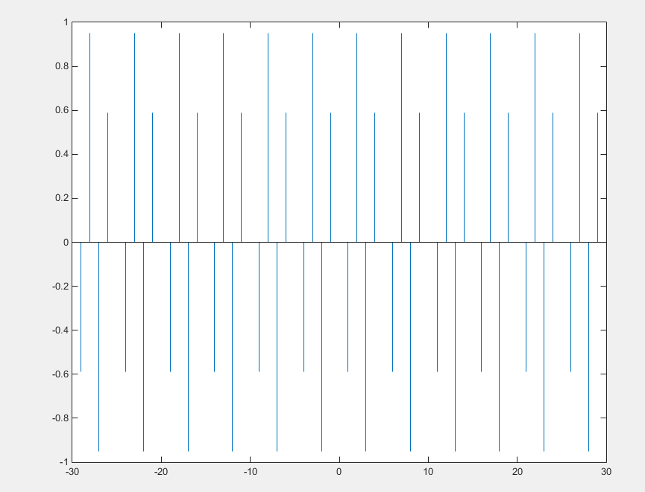

周期

所以 周期为 5

**第九题：**

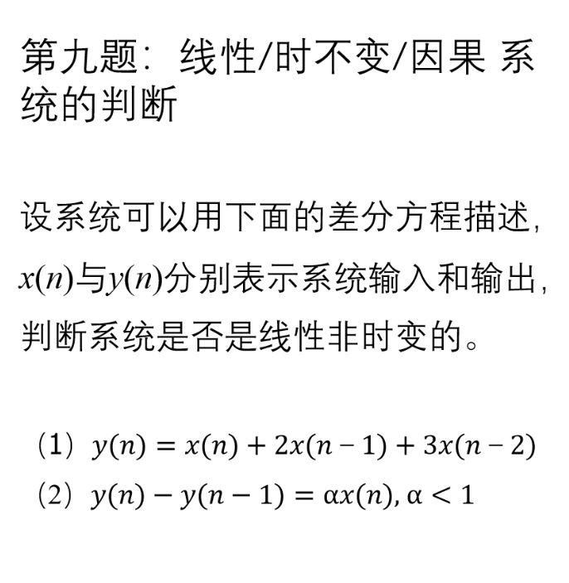

1. 线性性：

则

时不变性

令, 则有

（后面这个是的平移）

1. 线性性：

时不变性

令

是时不变的

**第十题：**

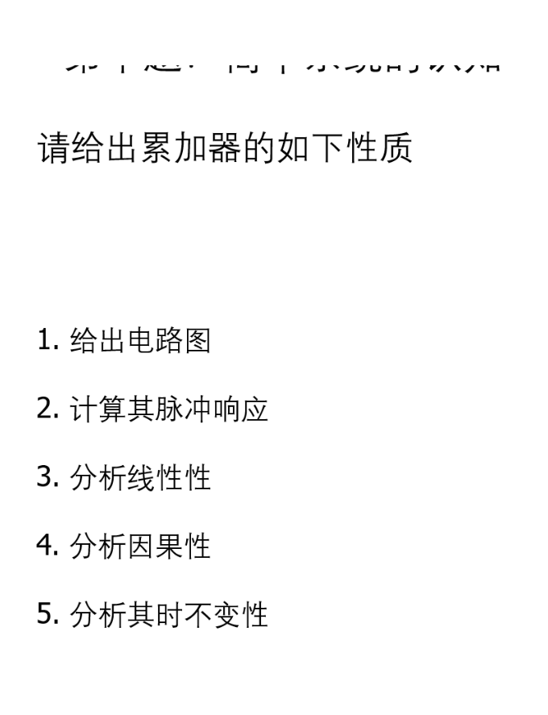

1）

2)其表达式为

则

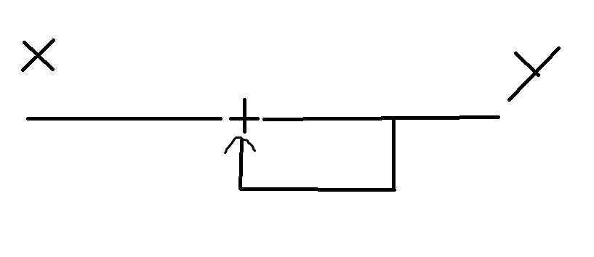

3) 由第九题可知， 累加器是线性性

4）由于是因果的， 所以对应的LTI系统是因果的

5）由第九题可知， 累加器是时不变性